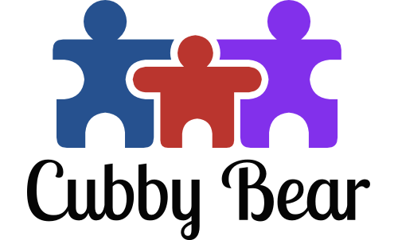
CONTRACT / HANDBOOK AGREEMENT

This agreement is made by and between Katie Hafenstein, Owner of Cubby Bear LLC and ____________________________________________________________,
Parent/Guardian of ______________________________________________________.
The following has been agreed upon between the two parties beginning on _____________________.
- I have read and I agree to the full contents of the Parent Handbook that I received in my enrollment packet. I understand that disregarding these policies can result in termination from child care enrollment.
- I understand that I must follow the termination policy as it is written in the Parent Handbook and give at least a 2 week notice before leaving Cubby Bear LLC
- I agree to the amount of $______________, to be paid to Cubby Bear LLC weekly on Friday before 2:00 pm for the following week's care.
- I agree to follow the attached schedule to the best of my ability for the days contracted. Any added time before or after those times will be discussed beforehand or will be subject to late pickup fees or early arrival fees.

This agreement shall be in effect until the parent/guardian or owner of Cubby Bear LLC has given termination notice in accordance with the Parent Handbook policy, or negotiation of a new contract.

THIS AGREEMENT AND THE PARENT HANDBOOK WHOLLY STATE THE OBLIGATIONS OF THE OWNER; THERE ARE NO OTHER IMPLIED OBLIGATIONS. ANY AMENDMENTS TO THIS AGREEMENT MUST BE IN WRITING AND SIGNED BY BOTH PARTIES.

___________________________________ ________________
Katie Hafenstein, Owner Date

___________________________________ ________________
Parent / Guardian Date

